Date: ________________, 2021

Thank you for purchasing ______ Real Christmas Tree(s) at _______________________ to be sent to a military family as part of the Christmas SPIRIT Foundation’s Trees for Troops Program.
The total purchase of the tree(s) was $________.
The Christmas Spirit Foundation is recognized by IRS as a 501(c)(3) public charity. Please consult your tax advisor regarding this contribution.

Sincerely,
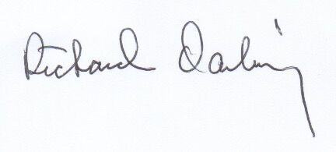
Richard Darling
Chairman, Christmas SPIRIT Foundation
2650 S. Hanley Rd., Ste. 100 • St. Louis, MO • (314) 416-2245 • (314) 845-1891 (fax) • www.TreesforTroops.org
----------------------------------------------------------------------------------------------------------------------------------------------
Date: ________________, 2021

Thank you for purchasing ______ Real Christmas Tree(s) at _______________________ to be sent to a military family as part of the Christmas SPIRIT Foundation’s Trees for Troops Program.
The total purchase of the tree(s) was $________.
The Christmas Spirit Foundation is recognized by IRS as a 501(c)(3) public charity. Please consult your tax advisor regarding this contribution.

Sincerely,
Richard Darling
Chairman, Christmas SPIRIT Foundation
2650 S. Hanley Rd., Ste. 100 • St. Louis, MO • (314) 416-2245 • (314) 845-1891 (fax) • www.TreesforTroops.org
----------------------------------------------------------------------------------------------------------------------------------------------
Date: ________________, 2021

Thank you for purchasing ______ Real Christmas Tree(s) at _______________________ to be sent to a military family as part of the Christmas SPIRIT Foundation’s Trees for Troops Program.
The total purchase of the tree(s) was $________.
The Christmas Spirit Foundation is recognized by IRS as a 501(c)(3) public charity. Please consult your tax advisor regarding this contribution.

Sincerely,
Richard Darling
Chairman, Christmas SPIRIT Foundation
2650 S. Hanley Rd., Ste. 100 • St. Louis, MO • (314) 416-2245 • (314) 845-1891 (fax) • www.TreesforTroops.org

